03E15 Teoría descriptiva de conjuntos

Definición y clasificación
Weisstein, Eric W. "Descriptive Set Theory," MathWorld--A Wolfram Web Resource. http://mathworld.wolfram.com/DescriptiveSetTheory.html .

http://www.encyclopediaofmath.org/index.php/Descriptive_set_theory:

03E30 Teoría axiomática de conjuntos
De http://www.encyclopediaofmath.org/index.php/Axiomatic_set_theory :

Axiomas ZFC

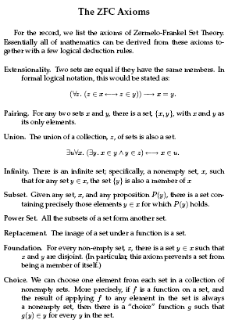
De Meyer, Rubinfeld: 6.042J / 18.062J Mathematics for Computer Science (http://ocw.mit.edu/NR/rdonlyres/Electrical-Engineering-and-Computer-Science/6-042JFall-2005/24EDE9CB-F22E-4383-8329-C48A15E63153/0/ln1.pdf)

Acordeón de Maxima: conjuntos

(%i1) set(a, b, a);
(%o1) {a, b}
(%i2) set();
(%o2) {}

(%i3) A: {a, b};
(%o3) {a, b}
(%i4) B: {c,d};
(%o4) {c, d}
(%i5) elementp(a,A);
(%o5) true
(%i9) intersection(A,B);
(%o9) {}
(%i10) powerset(A);
(%o10) {{}, {a}, {a, b}, {b}}

(%i3) cardinality ({a, a, b, c});
(%o3) 3
(%i4) cartesian_product ({0, 1}, {0, 1});
(%o4) {[0, 0], [0, 1], [1, 0], [1, 1]}
(%i5) s: divisors(28);
(%o5) {1, 2, 4, 7, 14, 28}
(%i6) disjoin(28,%o5);
(%o6) {1, 2, 4, 7, 14}
(%i7) lreduce ("+", args(s)) - 28;
(%o7) 28
(%i8) elementp(28,%o5);
(%o8) true
(%i9) elementp(28,%o6);
(%o9) false
(%i10) makeset (i/j, [i, j], [[1, a], [2, b], [3, c], [4, d]]);

1 2 3 4
(%o10) {-, -, -, -}
a b c d
(%i11) permutations ([a, b, c]);
(%o11) {[a, b, c], [a, c, b], [b, a, c], [b, c, a], [c, a, b], [c, b, a]}

(%i39) map (f, {a, b, c});
(%o39) {f(a), f(b), f(c)}

(%i40) s: {a, b, c};
(%o40) {a, b, c}
(%i41) for si in s do print (concat (si, 1));
a1
b1
c1
(%o41) done

Clases
Véase http://www.encyclopediaofmath.org/index.php/Class

